
Tribhuvan University
Faculty of Humanities and Social Science

STOCK PORTFOLIO TRACKER

A PROJECT REPORT

Submitted to
Department of Computer Application
Pascal National College

In partial fulfillment of the requirements for the Bachelors in Computer Application

Submitted by
Bikash Shrestha | 6-2-1226-5-2020
Yogendra Saud | 6-2-1226-31-2020
December 2023

Under Supervision of
Ashok Kumar Pant

Tribhuvan University
Faculty of Humanities and Social Science
Pascal National College

SUPERVISOR’S RECOMMENDATION

I hereby recommend that this project prepared under my supervision by BIKASH SHRESTHA and YOGENDRA SAUD entitled “STOCK PORTFOLIO TRACKER” in partial fulfillment of the requirements for the degree of Bachelor of Computer Application is recommended for the final evaluation.

Ashok Kumar Pant
SUPERVISOR
Principal, Faculty Member
Department of Computer Application
Pascal National College, Satdobato, Lalitpur


Tribhuvan University
Faculty of Humanities and Social Science
Pascal National College

LETTER OF APPROVAL

This is to certify that this project prepared by BIKASH SHRESTHA and YOGENDRA SAUD entitled “STOCK PORTFOLIO TRACKER” in partial fulfillment of the requirements for the degree of Bachelor in Computer Application has been evaluated. In our opinion it is satisfactory in the scope and quality as a project for the required degree.
Ashok Kumar Pant  Principal, Faculty Member  Department of Computer Application  Pascal National College  Satdobato, Lalitpur | Kabindra Koirala  BCA Coordinator  Department of Computer Application  Pascal National College  Satdobato, Lalitpur
Basanta Chapagain  (Internal Examiner) | Er. Shree Krishna Maharjan  (External Examiner)

ABSTRACT
In this project, we built the web application that provide user transaction upload feature and generate portfolio, sectors, instruments and holdings summaries based on transactions data to assist individuals in effectively managing their stock portfolios and making informed investment decisions. This application focuses in the diversification of portfolio by providing summary generation with the selection of their sectors and instruments and the company’s transaction summary. This application calculates stats such as total available units, current value of stocks, total investments, realized profit/loss, overall profit/loss, average cost of stock and many more by reading transactions data – traded price, buy/sold units. Features like searching the company based on their stock symbol and provide the company’s detail information including their transactions makes application more different. By leveraging visualizing tools and informative stats, our application provides the necessary resources to make informed investment decisions and monitor the performance of their stock portfolios effectively.
Keywords: portfolio tracker, portfolio summary generator, stock tracking, NEPSE

ACKNOWLEDGEMENT
We would like to express our heartfelt gratitude and appreciation to all those who have supported and guided us throughout the development of the Stock Portfolio Tracker application.
First and foremost, we would like to extend our deepest thanks to our project supervisor, Ashok Kumar Pant and our coordinator Kabindra Koirala, for their invaluable guidance, expertise, and constant support. Their mentorship and constructive feedback have been instrumental in shaping the project and pushing us to deliver our best.
We would also like to acknowledge the contribution of our teammate, who has been an integral part of this project. Their dedication, hard work, and collaboration have been key factors in the successful completion of this endeavor.
Lastly, we would like to acknowledge the countless individuals who have shared their knowledge and expertise, either through discussions, feedback, or research materials. Your contributions have greatly enriched our understanding and helped shape the final outcome of this project.
In conclusion, we are truly grateful to all those mentioned above and to anyone else who has contributed to the success of this project. Your support, guidance, and encouragement have played a vital role in our journey, and we extend our heartfelt thanks to each and every one of you.

Sincerely,
Bikash Shrestha and Yogendra Saud

LIST OF ABBREVIATIONS
API Application Programming Interface
CSS Cascading Style Sheet
CDSC Central Depository System and Clearing
DFD Data Flow Diagram
ER Entity Relation
HTML Hyper Text Markup Language
IDE Integrated Development Environment
JS JavaScript
LTP Last Transaction Price
MVC Model View Controller
NEPSE Nepal Stock Exchange
PHP Hypertext Preprocessor
REST Representational State Transfer
TMS Trading Management System
UI User Interface
VS Code Visual Studio Code

LIST OF FIGURES
Figure 3. 1 Use-case diagram of stock portfolio tracker 9
Figure 3. 2 Gantt chart of schedule timeline 11
Figure 3. 3 Entity-relation diagram of stock portfolio tracker 12
Figure 3. 4 Level 0 DFD of stock portfolio tracker 13
Figure 3. 5 Architecture design of stock portfolio tracker 14
Figure 3. 6 Database schema of stock portfolio tracker 15
Figure 3. 7 Interface design of portfolio tracker 16
Figure 3. 8 UI design of dashboard page 17
Figure 3. 9 UI design of signup 18
Figure 3. 10 UI design of login 18
Figure 3. 11 Physical level DFD of stock portfolio tracker 19
Figure 3. 12 System function module of stock portfolio tracker 22

LIST OF TABLES
Table 4. 1 Test table for signup 35
Table 4. 2 Test table for login 36
Table 4. 3 Test table for logout 36
Table 4. 4 Test table for upload 37
Table 4. 5 Test table for update 38
Table 4. 6 Test table for delete 38
Table 4. 7 Test table for authentication system 39
Table 4. 8 Test table for reporting system 40
Table 4. 9 Test table for searching system 40

TABLE OF CONTENTS
SUPERVISOR’S RECOMMENDATION i
LETTER OF APPROVAL ii
ABSTRACT iii
ACKNOWLEDGEMENT iv
LIST OF ABBREVIATIONS v
LIST OF FIGURES vi
LIST OF TABLES vii
CHAPTER 1: INTRODUCTION 1
1.1 Introduction 1
1.2 Problem Statement 2
1.3 Objectives 3
1.4 Scopes and Limitation 4
1.4.1 Scopes 4
1.4.2 Limitations 4
1.5 Report Organization 5
CHAPTER 2: BACKGROUND STUDY AND LITERATURE REVIEW 6
2.1 Background Study 6
2.2 Literature Review 8
CHAPTER 3: SYSTEM ANALYSIS AND DESIGN 9
3.1 System Analysis 9
3.1.1 Requirement Analysis 9
3.1.2 Feasibility Analysis 10
3.1.3 Data Modelling 12
3.1.4 Process Modelling 13
3.2 System Design 14
3.2.1 Architectural Design 14
3.2.2 Database Schema Design 15
3.2.3 Interface Design 16
3.2.4 UI Design 17
3.2.5 Physical DFD 19
CHAPTER 4: IMPLEMENTATION AND TESTING 20
4.1 Implementation 20
4.1.1 Tools Used 20
4.1.2 Implementation Details of Modules 22
4.2 Testing 35
4.2.1 Test Cases for Unit Testing 35
4.2.2 Test Cases for System Testing 39
CHAPTER 5: CONCLUSION AND FUTURE RECOMMENDATIONS 41
5.1 Lesson Learnt / Outcome: 41
5.2 Conclusion: 41
5.3 Future Recommendations: 41
REFERENCES 42
APPENDICES 43
Source Code 43
Screenshots 50

CHAPTER 1

INTRODUCTION

1.1 Introduction
Portfolio is partly based on the Latin folium, meaning "leaf, sheet". A portfolio usually represents a portable showcase of your talents. [1]
A portfolio is a collection of financial investments like stocks, bonds, commodities, cash, and cash equivalents, including closed-end funds and exchange traded funds (ETFs). [2]
The stock portfolio tracker application is the tool to create and manage their stock portfolios, analyze performance, and generate meaningful summaries which helps in gaining insights and overview of user’s historical investments and also look at the current performance of the stock.
Users are able to analyze portfolio diversification by filtering based on sectors, instruments and type of stocks, evaluate performance metrics, and reports based on their history transactions. The application also provides users with a seamless and intuitive user interface, enabling them to add or upload stocks transactions, track stock prices, and access historical transactions data. The application provides an overview of how specific stock transactions has benefitted the user or not. The project uses the third-party API to gain the stock day prices and closing prices which even helps more for making investment decisions further.
The application's intuitive interface, day to day data updates, and summarizing capabilities will empower users to optimize their investment strategies and achieve their financial goals in the dynamic world of the Nepalese stock market.

1.2 Problem Statement
With the increasing popularity of stock trading and investment, there is a growing need for a user-friendly tool that provides real-time data updates, portfolio tracking capabilities, and analytical insights tailored to the context of the Nepalese stock market.
As investments develop and become more diversified, keeping an eye on everything becomes more difficult. [3]
Many people throw a lot of money for managing their portfolio. [4]
The problem is that for people with investments scattered across several sectors and industries platforms and asset classes. How does user stay up-to-date and on top of their investments and their performance?
User could either use a spreadsheet or automate the process with an investment portfolio tracker. Since using spreadsheet software is time consuming which requires manual effort to input data and doesn’t provide the informative summary and insights from it. It also lacks the ability to visualize the changing data effectively to the user. It requires even more harder to display the diversification insights of the stock and their performance in spreadsheet.
The user doesn’t have enough time to add entire transactions manually to get portfolio status and summary, which is just frustrating to user. This project is focused to solve that problem by giving user to option to upload their transactions data.
Also, the most of available tools in current market doesn’t support the ability to upload transactions, still requires manual input of every single transaction and doesn’t provide the detailed summary of the portfolio. Existing solutions in the market often lack user-friendly interfaces as well. After buying and selling thousands of companies’ stock, it’s hard to remember all the profits and losses that investor gained or loss.
So, these challenges create a need for a simple and intuitive tool that allows users to effortlessly track their stock holdings and monitor their performance and generate report or information on based of transactions which can be used for making further investments decision.

1.3 Objectives
- To develop a system that provide stock’s performance such as profit & loss information to individuals.
- To develop a system that provide stocks summaries based on their selection of sectors and type of stock.
- To develop a system that provide user transaction upload features and generate portfolio, sectors, instruments and holdings summaries based on transactions data.

1.4 Scopes and Limitation

1.4.1 Scopes
- It can be further developed into full-fledged stock application with more portfolio management features, including the ability to create, customize, and manage multiple portfolios.
- The integration of real-time stock data from Meroshare and NEPSE APIs can ensures that users have access to the most current market information, allowing for timely decision-making.
- The application is designed with scalability in mind, making it possible to add new features and expand its capabilities in the future.

1.4.2 Limitations
- The application is not fully automated and relies on third party APIs for stock price information so, may not show real time up to date data.
- The application is specifically tailored to the Nepalese stock market - NEPSE portfolios so, transactions data needs to be in specified format as in Meroshare.

1.5 Report Organization
The first chapter of the report contains the summarized introduction of the whole project report. It includes the overview, scope and limitation, problem statement and objectives of this project.
The second chapter includes background study i.e., description of fundamental theories, general concepts and terminology related to the project. It also includes the literature review i.e. review of the similar projects, research and theories done by others.
The third chapter includes the system analysis and design phase in which the report of functional and non-functional requirements of the project is stated using use case and system diagrams. It also includes the feasibility study about the system which explains whether the system development process is affordable and within the knowledge range of the developers. It shows the technical, operational and economic feasibility of the project development phase. The explanation of the designing of the system is also done in this chapter. It includes data modeling and process modeling which is explained by using ER diagram and Data Flow Diagram. The architectural design, database design and the user interface design are also listed in this chapter.
The fourth chapter includes the implementation and testing phase of the proposed system. In the implementation phase, it includes how the tools like CASE tools, programming languages and database platforms are implemented. In testing, it includes the test cases tables for unit testing and system testing.
The fifth chapter includes conclusion and future recommendation. It contains the final paragraphs of the report and in this phase the overall outcome and the developer point of view is written. The lesson that we learned through all the phases is included in this chapter.

CHAPTER 2

BACKGROUND STUDY AND LITERATURE REVIEW

2.1 Background Study
Stock Portfolio Tracking includes tracking of all historic transactions, summarizing those transactions. It tracks the diversification of stock investment. It tracks the overall profit and losses and visualize them. It requires number of units, trade date, balance before transactions… etc.
Since, this project application is mainly focused portfolio management of Nepal Stock Exchange companies only. Stock companies listed in NEPSE are divided into different sectors like commercial banks, hydropower, life insurances, microfinances etc. also into different stock types like Mutual funds, Debentures and Equity. Some companies may show up in Meroshare but is not publicly traded in NEPSE so those type of company may not be calculated in generation of report.
Meroshare provides all the necessary transactions details of user. In order to calculate summaries and generate stats of the portfolio the application need user transactions details. Meroshare transactions doesn’t include the buying or selling price of the stock so this project makes assumptions that buying and selling price is given in order to calculate overall profits and losses. For real report generation, user can add their transactions traded unit price details from their brokerage TMS, which needs to be added manually.
All the stock companies’ information were gathered from publicly available official NEPSE website. Sector and Instrument wise summary requires the sector and type of stock company details as well. Stock company prices fluctuates day to day and user may trade the stock in different prices. In order to calculate current value of the stock company we need day to day closing price and previous day closing price. Also, for report calculations of the current holdings, investment value and current value. The stock prices were fetched from third party API. API only provides prices data at the end of the trade day. So, this project made the assumption of getting live price as well.

Terminologies related to the project:
Meroshare: A web application that provides the facility to the beneficiary to view the stock transaction information online.
Scrip: Public company symbol to identify uniquely
Units: Quantity of shares or stocks
Instrument: Type of investments such as debentures or mutual funds or equity funds
Sectors: Companies are divided int different categories
LTP: The last transaction traded price of the stock
Brokerage: The business entity which manages and handles all the stock transactions.
TMS: Trading management system provided by NEPSE to all brokers

2.2 Literature Review
The project topic is very comparatively new and the research paper and the article directly related to this topic were not easily reviewed in context of Nepalese stock market. So, there is not enough availability of research papers and project-based on portfolio management.
Many references and ideas were gathered from third-party portfolio management tools such as Sastoshare, Nepali Paisa, MeroLagani, Chukul, Smart Wealth Pro, Nepal Share, Neex etc. are only available commercially. The idea of differentiation of portfolio summary and holdings is referenced from the India based stock brokerage company Zerodha, the primary features such as averaging investment cost, profit and loss etc. are calculated observing the Kite demo website. Also, the design feature such as minimal and subtle looks to website is also referenced from it.
Portfolio management is an important financial skill for active investing. [2]
Diversification is a key concept in portfolio management. [5]
One of the key concepts in portfolio management is the wisdom of diversification—which simply means not putting all of your eggs in one basket. Diversification tries to reduce risk by allocating investments among various financial instruments, industries, and other categories. [6]
After reviewing the article from web, we found out that portfolio management is the must skill for investing and to maximize the profits and gains from diversification of assets is also important. So, this application focuses to solve that problem of diversification which are hard to visualize without the portfolio management tool, it makes user conscious about their investment by providing user the report and summaries based on selection of sectors and instruments for making better financial decision.

CHAPTER 3

SYSTEM ANALYSIS AND DESIGN

3.1 System Analysis

3.1.1 Requirement Analysis

A. Functional Requirement:
- The application should be able to register new users.
- The application should be given access the user with their valid login credentials.
- The application should be able to upload valid transactions file.
- The application should be able to show information about stock companies.
- The application should generate reports about stocks profit and losses.
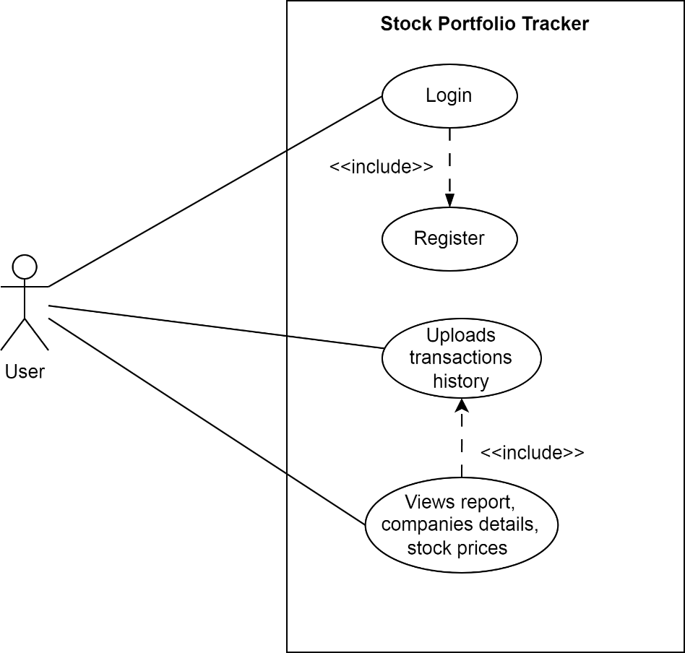
Figure 3. 1 Use-case diagram of stock portfolio tracker

B. Non-Functional Requirement:
- The application should be secured.
- The application should have easy to use interface.
- The application should be faster in performance.
- The application should have feature to search for stock information.
- The application should be interactive user interface.

3.1.2 Feasibility Analysis

A. Technical
This project only needs the user transactions and stock information which is available. It can be done using existing web technologies and tools so there is no difficulty in developing this project. Since, this project is based on assumptions of user’s transactions data.

B. Operational
This project is simple and intuitive, using this application doesn’t require extra knowledge. It is very user-friendly and can be easily adapted by any new user that will use this website. As it uses well-known web technologies, it is easy to maintain.

C. Economic
This project is very cost-friendly as it uses existing free technologies like FastAPI, SQLite, VS Code and open-source tools. There is no cost for the tools that are being used. This project didn’t require money for its development. The only thing is to be done is making an environment for the development with an effective supervision.

D. Schedule
This project is simple so it is schedule according to water fall methodology, dividing first two weeks gathering requirements and designing the application. We are familiar with this type of project, so it is schedule properly.
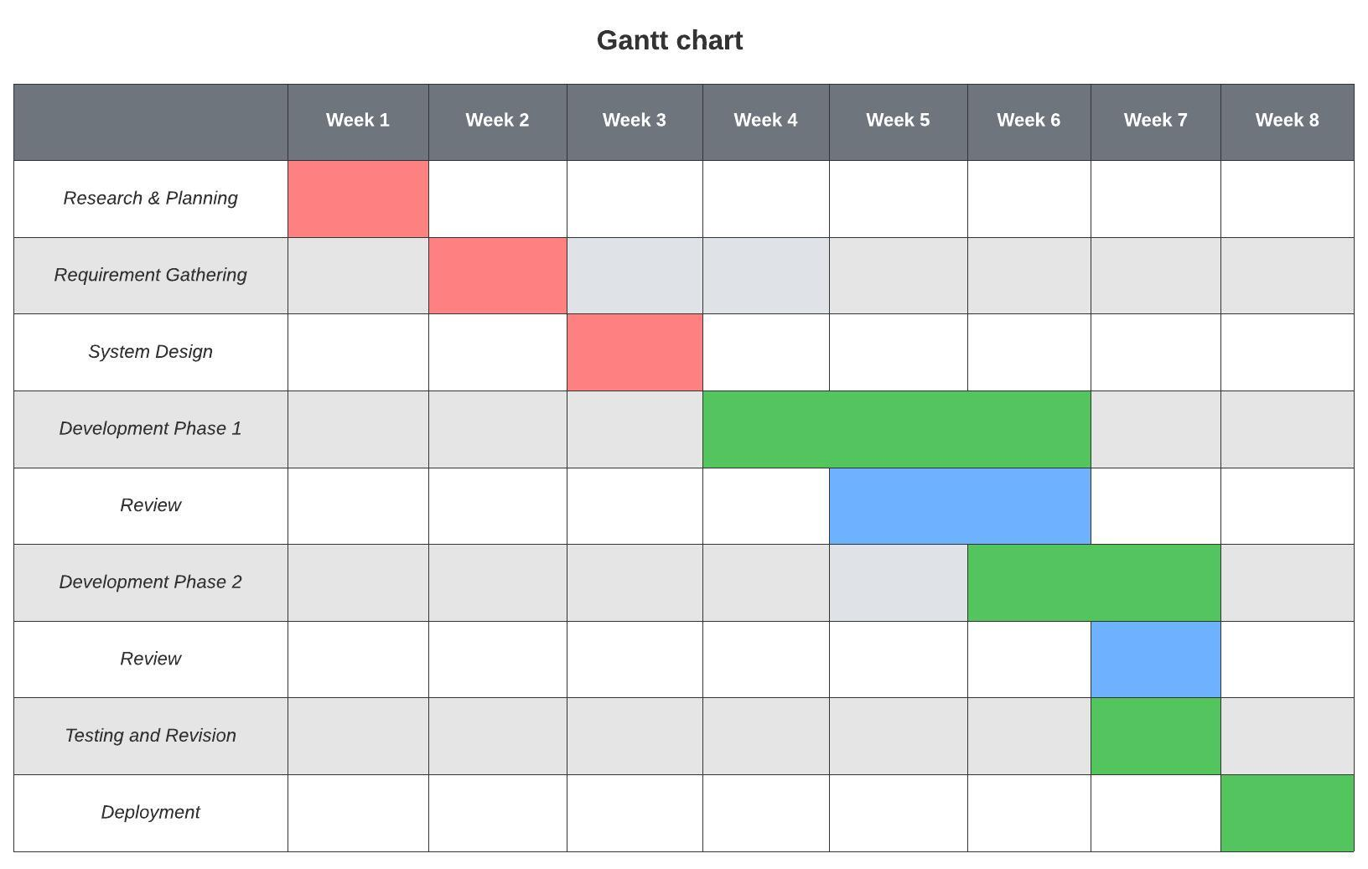
Figure 3. 2 Gantt chart of schedule timeline

3.1.3 Data Modelling
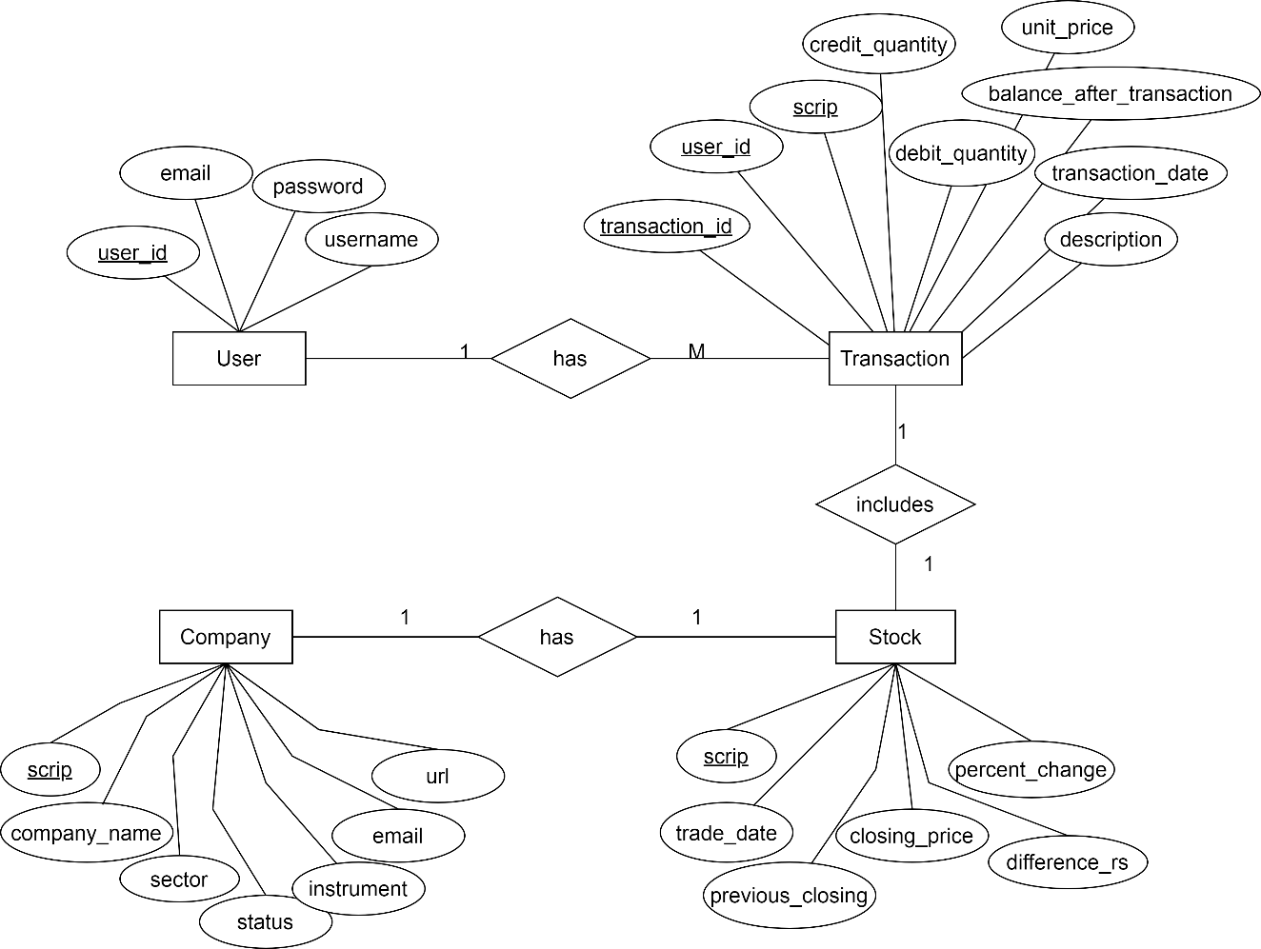
Figure 3. 3 Entity-relation diagram of stock portfolio tracker
In this ER Diagram, a User have their own Stock Transaction history. Each Stock Transaction is associated with a specific Stock, representing the transaction details for a particular stock. The Stock entity represents different stocks available for trading. The Stock entity stores the price information for each stock on different dates, including the closing price (Last Traded Price) and the price of the previous day (previous_closing). Company entity provides the Stock symbol and further information such as status, instrument, sector ...etc.
The relationships in this schema are as follows:
- The "has" relationship connects User to Transaction, indicating that a User can have multiple stock transactions.
- The "includes" relationship connects Transaction to Stock, specifying the stock involved in a particular transaction.
- The "has" relationship connects Stock to Company, indicating that a Stock can have only one company.

3.1.4 Process Modelling

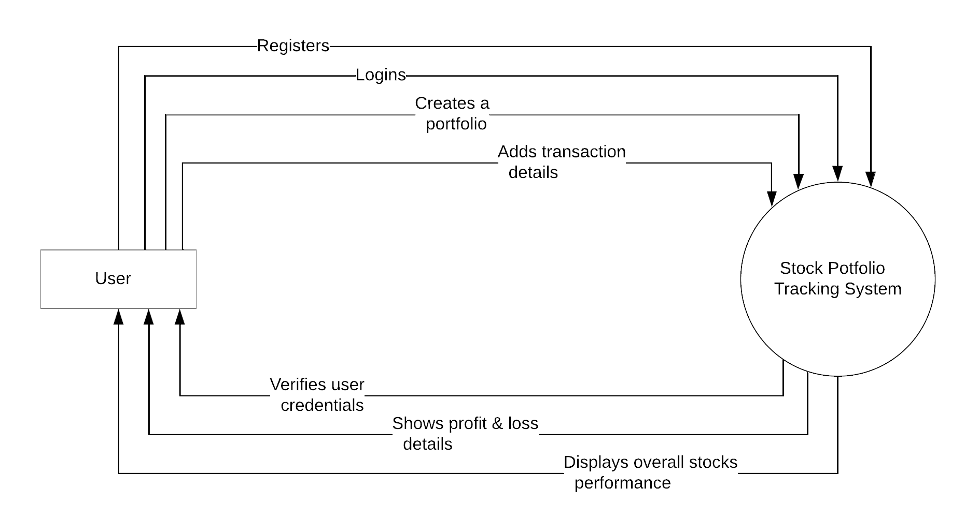
Figure 3. 4 Level 0 DFD of stock portfolio tracker
Explanation:
- The Stock portfolio tracking application interacts with two main entities: the User and the Stock Portfolio Tracking System.
- The User represents the individuals who interact with the application through the web interface.
- The Web Interface provides the user interface through which users can interact with the application, including logging in, managing portfolios, adding/removing stocks, and accessing reports.
- The Stock Portfolio Database stores all the relevant data, including user information, portfolio details, stock information, and generated reports.
- The flow of data in this context level diagram is represented as a single arrow from the User to the Web Interface and from the Web Interface to the Stock Portfolio Database, indicating the exchange of information and data between these components
This context level data flow diagram provides a high-level overview of the stock portfolio web application, focusing on the key entities and their interactions. It serves as a foundation for developing more detailed data flow diagrams that capture the processes, data transformations, and interactions within the application.

3.2 System Design

3.2.1 Architectural Design

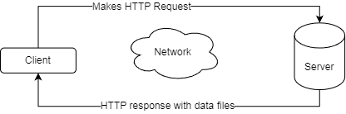
Figure 3. 5 Architecture design of stock portfolio tracker
This project is based on the client-server architecture model. This architecture was chosen because it separates application logic and data or repository from the program which makes project cleaner and easier to understand the elements.
Client-side includes all the tools and resources the application needs to run whereas server-side handles the client requests and provides the file required. In this project, server is responsible for all application logic such as session verification, report generation etc.
Models of the repository:
  - User (user_id, username, email, password)
  - Company (scrip, company, status, email, url, instrument, sector)
  - Transaction (scrip, traded_price, credit, debit, balance unit, description, trade_date)
  - Stock (scrip, closing_price, previous_closing, trade_date, percent_change)
Templates:
  - Dashboard, Holdings, Upload, Transactions view, Prices view, Company view
Controllers:
  - Authentication service – controls user authentication
  - Stock service – controls stock prices and API data
  - Transaction service – controls transaction information
  - Company Service – controls the company information

3.2.2 Database Schema Design

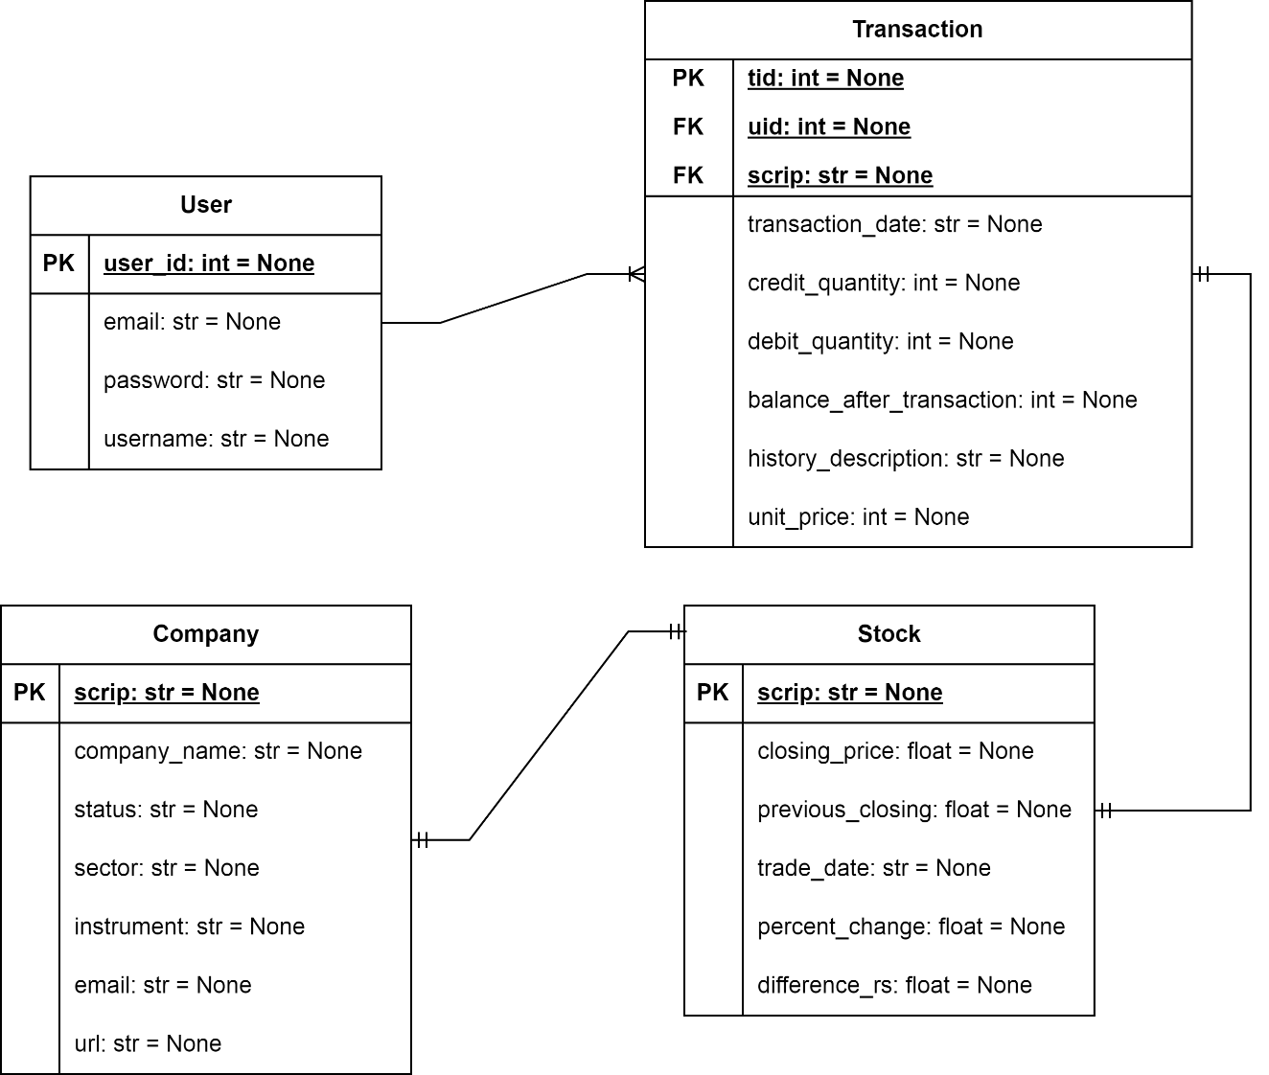
Figure 3. 6 Database schema of stock portfolio tracker
The above figure is the database schema of the Stock Portfolio Tracker application.
It includes the main 4 relation entities;
- User having attributes user_id, username, email and password which helps to verify the user.
- Transaction having attributes unit_price, transaction_date, credit, debit quantity, history_description with foreign keys uid, scrip and primary key tid.
- Stock having attributes closing price, previous day closing, trade date, change in percent.
- Company having company name, email, status, sector info and instrument mean type of stock.

3.2.3 Interface Design

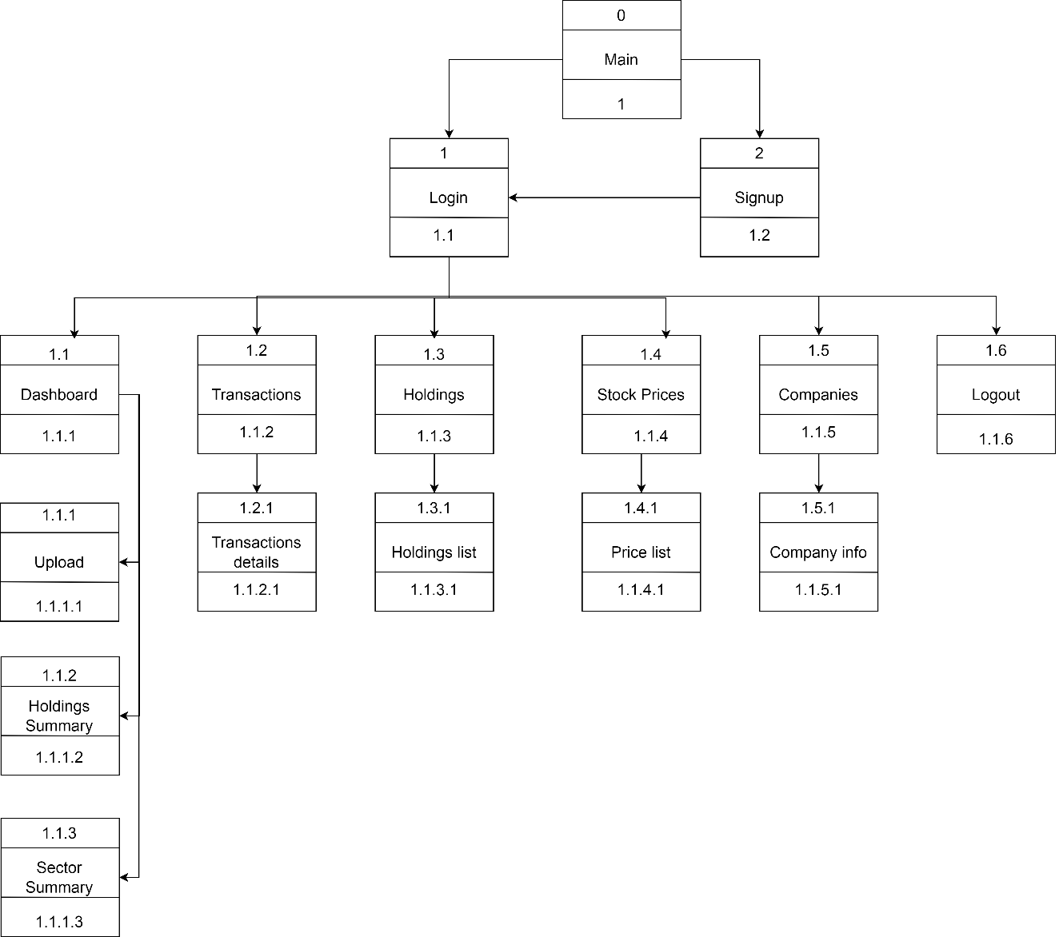
Figure 3. 7 Interface design structure of portfolio tracker
The above diagram shows the link and menus to navigate through the application. The base page shows the login and signup option. If the user is already registered, he/she can login with valid credentials, which takes them to dashboard which contains upload option so that use can upload transaction history which will show the summary of transactions. User can also view the stock prices, companies’ information, holdings details and can logout after looking at the report.

3.2.4 UI Design
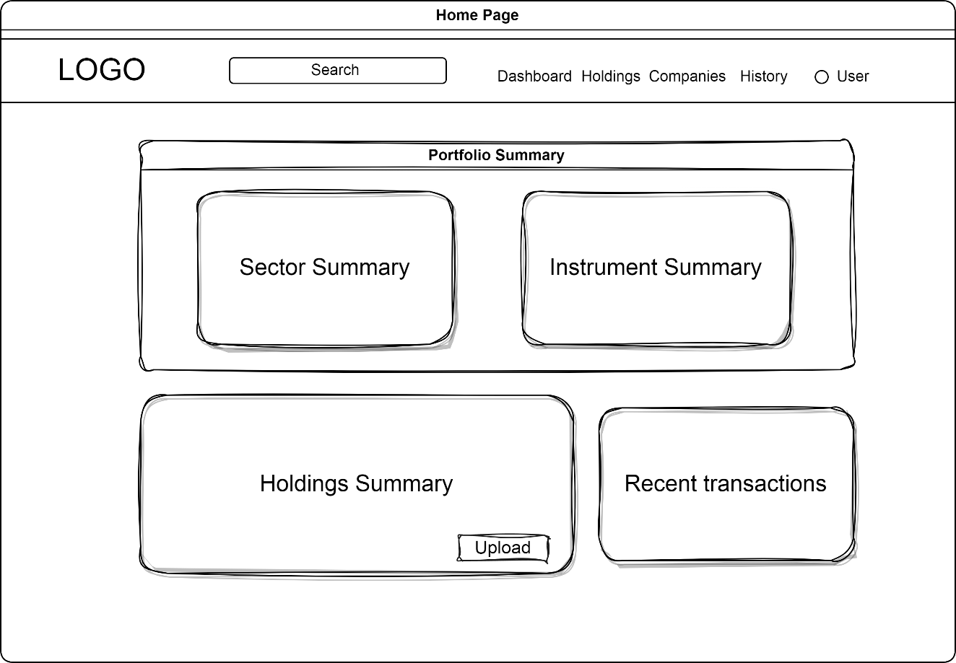
Figure 3. 8 UI design of dashboard page
The dashboard interface includes navigation options such as holdings, companies, history and user profile. The dashboard contains the further sections of summaries of the portfolio, recent transactions, holdings etc. information. User can easily upload transaction file and logout after finishing the work.

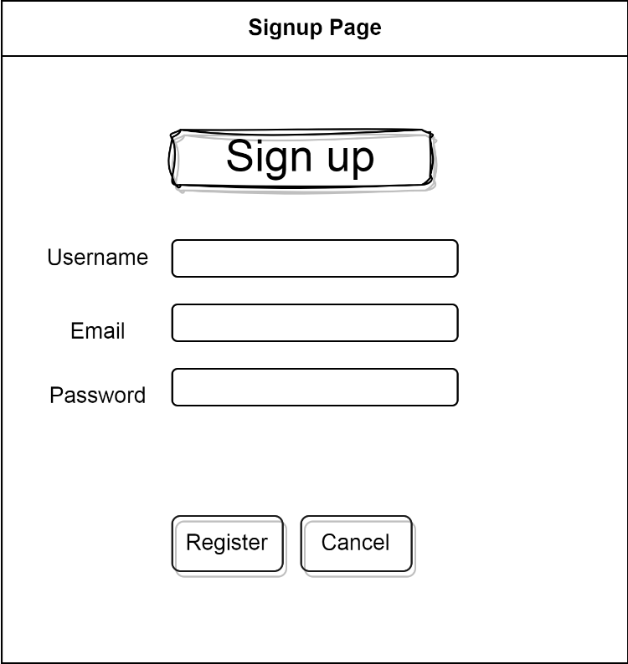
Figure 3. 9 UI design of signup

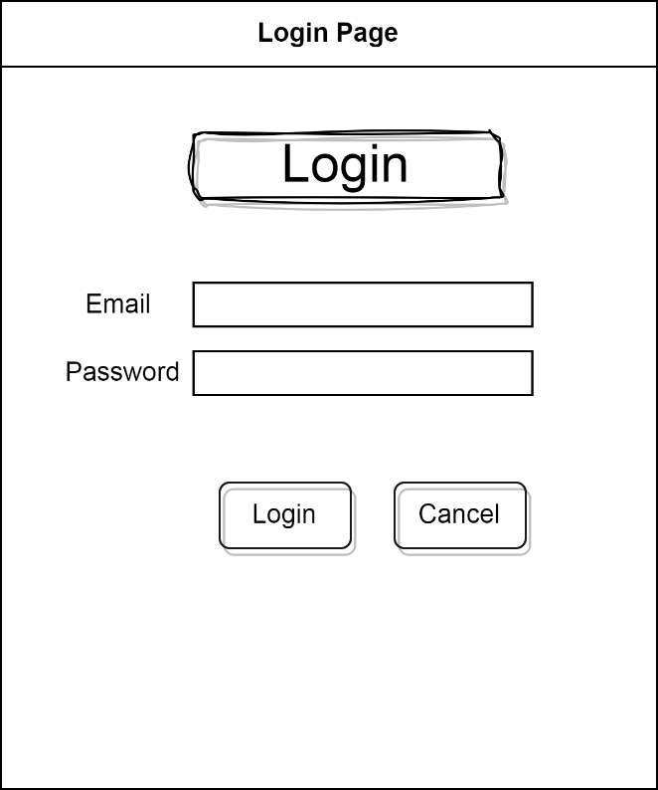
Figure 3. 10 UI design of login

3.2.5 Physical DFD
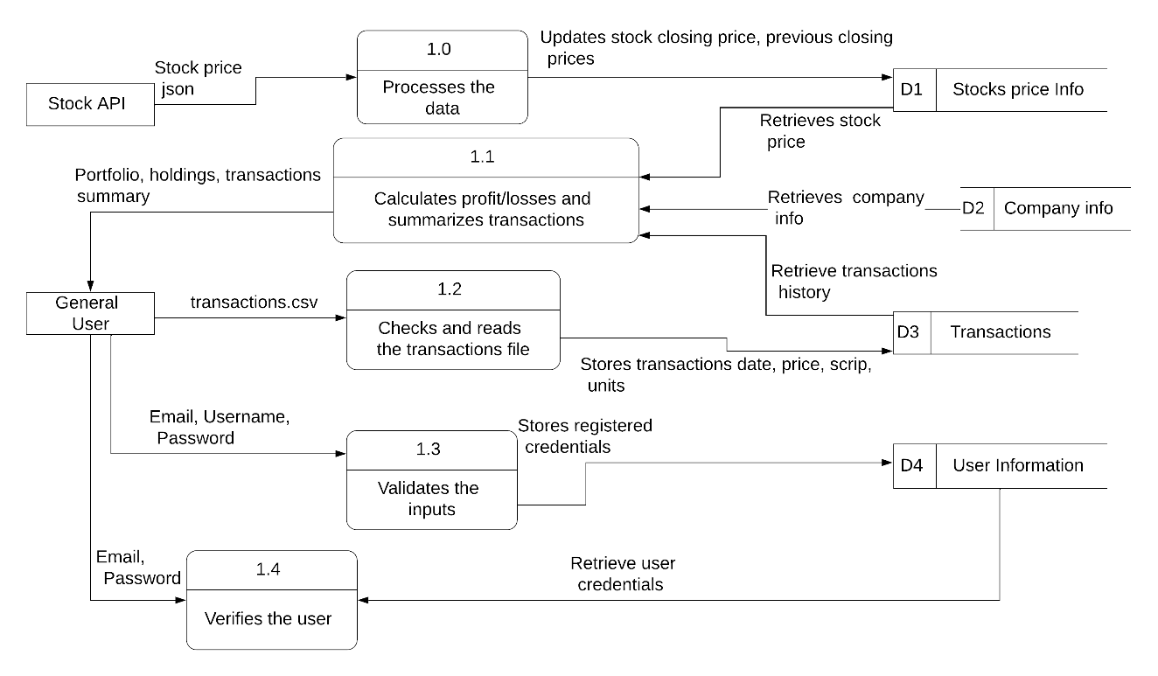
Figure 3. 11 Physical level DFD of stock portfolio tracker
In above diagram, it shows there are two entities General user and Stock API.
- The Process 1.0 work is to retrieve the stock prices and process data which is in raw JSON format from the Stock API.
- The Process 1.1 collects all the data necessary for generating summaries and reports from all the databases which is the send to General user as information.
- User can upload their transaction history in csv file format which is then checked and read by Process 1.2 and sends to store the transaction into Transaction database.
- The general user registers by giving email, password username which is validated by Process 1.3 and sends to User database to store after validation.
- While registered user is able to login after entering valid credentials which is verified by Process 1.4.

CHAPTER 4

IMPLEMENTATION AND TESTING

4.1 Implementation

4.1.1 Tools Used

Integrated Development Environment:
VS Code: As an IDE, we used VS Code which is easy to use and very lightweight. We were familiar with this IDE. It is easy to setup and supports many extensions working with project.

Diagram tool:
Draw.io: We mostly used draw.io for making ER models, UI/ Interface design, Database schema design and System architecture design.
Lucidchart: Level 0 DFD, Physical DFDs, Gantt Chart, System flowchart and others were made using web-based diagram tool Lucidchart.

Programming Languages:
Python: We used python as a primary language for our application logic because we’re familiar and comfortable with it. Also, it has built in features which are easy to use and online community with great supports.
FastAPI: We used FastAPI for routing endpoints and rendering templates because it is for building RESTful APIs in Python. We chose this framework from other frameworks such as Django, Flask because it is lightweight and easy to use with built in OpenAPI docs.
Jinja: Since, Python code doesn’t work inside the HTML like PHP, so we used Jinja as templating engine.
Chart.js: For displaying doughnut chart for sector wise distribution of holdings.
HTML: We used as usual HTML for structuring the application webpages.
CSS: It is used for all styling of webpages in our application.
JS: JavaScript is used for interactive behavior of application like for profile options, search suggestions etc.

Database platform:
SQLite3: In this project, we used SQLite3 database for storing data which is directly supported by python and easy to work with.

Documentation Tool:
MS Word: For this project, we used the Microsoft Word as a documentation tool.

Configuration Management Tool:
Git: For this project, we used git as version control system for our application.
Github: We used GitHub as a platform so that we can work remotely, on different tasks.

4.1.2 Implementation Details of Modules

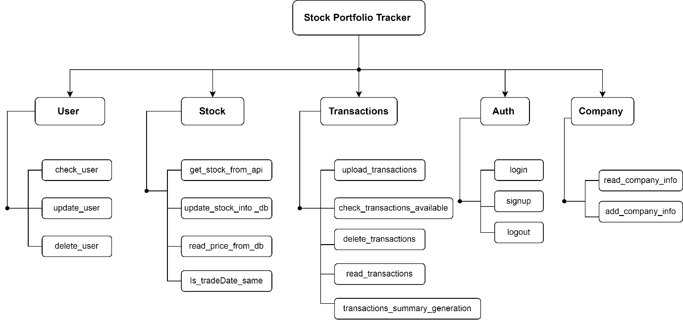
Figure 3. 12 System function module of stock portfolio tracker
Above Fig 11. is the implementation structures of modules which includes five modules: user, stock, transactions, authentication and company module. Each module has their own functions.
Note: All the functions related to repository class is in appendix.

User module:
This module includes function like read_user, update_user and delete_user to read, update and delete user credentials.
Reading user credentials:

Deleting user credentials:
Updating user credentials:
The update user credentials include updating of username, email and password. All of the update function needs new credentials and old password as a parameter.

Stock Module:
This module includes function like get_stock_prices_from_api(), update_prices_to_db, get_all_stock_prices and check_tradeDate().
Reading stock prices from API:

Update stock prices into database:
This function is to add stock prices into database after reading from API.

Reading stock prices from database:
Check database stock prices:
This function is to check whether database trade date is same as API trade date in order to prevent updating whole stock prices database each time reloading.
def is_tradeDate_same_db(self):
from portfoliotracker.repo import TransactionRepo
from portfoliotracker.repo.db import get_db_connection
db = get_db_connection()

trans_repo = TransactionRepo(db)
api_date = self.get_stock_prices_from_api().result['result']['stocks'][1]['tradeDate']
db_date = trans_repo.get_stock_tradeDate()
if api_date == db_date[0]:
return True
else:
return False

Transactions Module:
This module is responsible for all the reading, uploading of transactions. It also calculates and generate summaries based on it.
Reading the transaction file and uploading it to database:
def upload_transactions(self, user: User, file_location :str) -> BaseResponse:
with open(file_location, newline='') as csvfile:
reader = csv.DictReader(csvfile)
for row in reader:
try:
transaction = Transaction(scrip= row['Scrip'], transaction_date = date_format(row['Transaction Date']),credit_quantity = stringToInt(row['Credit Quantity']), debit_quantity = stringToInt(row['Debit Quantity']), balance_after_transaction = stringToInt(row['Balance After Transaction']),history_description = shorten_history(row['History Description']), unit_price = row['Unit Price'])
except Exception:
return BaseResponse(error=True, success=False, msg="CSV file is not valid in format!")
if not self.trans_repo.insert_transaction(user, transaction):
return BaseResponse(error=True, success=False, msg="Could not insert a transaction into db!")
return BaseResponse(error=False, success=True, msg="success")

stock_transactions_stats: This function is to calculate the stock stats of user based on stock symbol. It returns total invest, profit/loss, balance units, average cost, profit/loss percent, current value and overall profit/loss & percent.
def stock_transaction_stats(self, user:User, scrip:str):
total_invest_value = 0
total_sold_value = 0
total_credit_quantity = 0
total_debit_quantity = 0
total_profit_loss_percent = 0
total_profit_loss = 0
overall_percent = 0
overall_profit_loss = 0
total_credit_transactions_no = 0
net_change = 0
total_unit_price = 0
avg_invest_value = 0
average_cost = 0

prices = self.transactions_stock_price(scrip)
transactions = utils.dictifiy_transactions(self.trans_repo.retrieve_transaction_by_scrip(user, scrip))

for item in transactions:
if item['credit_quantity'] > 0:
total_credit_transactions_no = total_credit_transactions_no + 1
total_unit_price = total_unit_price + item['unit_price']
total_credit_quantity = total_credit_quantity + item['credit_quantity']
total_debit_quantity = total_debit_quantity + item['debit_quantity']

total_invest_value = total_invest_value + (item['credit_quantity'] * item['unit_price'])
total_sold_value = total_sold_value + (item['debit_quantity'] * item['unit_price'])

# print(item['scrip'], total_credit_transactions_no)
if total_credit_transactions_no >0:
average_cost = total_unit_price / total_credit_transactions_no

total_balance_quantity = total_credit_quantity - total_debit_quantity
current_value = prices.closing_price * total_balance_quantity
avg_invest_value = average_cost * total_credit_quantity
profit_loss = current_value - avg_invest_value

if avg_invest_value > 0:
net_change = round((profit_loss/avg_invest_value)*100, 2)
overall_profit_loss = (total_sold_value + current_value) - total_invest_value
if total_sold_value != 0:
total_profit_loss = total_sold_value - total_invest_value

if total_invest_value > 0:
total_profit_loss_percent = round((total_profit_loss / total_invest_value)*100, 2)
overall_percent = round((overall_profit_loss / total_invest_value)*100, 2)

return {"stockSymbol": scrip, "invest_value": total_invest_value, "sold_value": total_sold_value, "total_profit_loss": round(total_profit_loss, 2), "credit": total_credit_quantity, "debit": total_debit_quantity, "balance_quantity": total_balance_quantity, "total_profit_loss_percent": total_profit_loss_percent, "current_value": current_value, "overall_profit_loss": round(overall_profit_loss, 2), "overall_percent": round(overall_percent,2), "average_cost": round(average_cost, 2), "net_change": net_change, "profit_loss": round(profit_loss, 2), "avg_invest_value": avg_invest_value}

Check whether transactions data available or not:
def check_user_transactions(self, user:User)->bool:
if self.trans_repo.retrieve_all_transaction(user):
return True
return False

Delete the user transactions data:
def delete_transactions(self, user_id:int):
try:
result = self.trans_repo.delete_transaction(user_id)
return BaseResponse(error=False, success=True, msg="success", result=result)
except Exception as e:
return BaseResponse(error=True, success=False, msg = str(e))

Generate the transactions summaries and report:
Instrument summary: returns the instrument wise summary of the transactions
def instrument_summary(self, trans:dict, instrument: list):
instrumentInfo = []
for ins in instrument:
count = 0
value = 0
for item in trans:
if item['instrument'] == ins[0]:
count = count + 1
value = value + item['closing_price'] * item['balance']
instrumentInfo.append(dict(instrument= ins[0], no_of_scrip = count, total_value= round(value, 2)))
return instrumentInfo

Sector summary: returns the sector wise summary of the transactions
def sector_summary(self, trans:dict, sectorList: list )-> list:
sectorInfo = []
for sector in sectorList:
count = 0
value = 0
for item in trans:
if item['sector'] == sector[0]:
count = count + 1
value = value + item['closing_price'] * item['balance']
sectorInfo.append(dict(sector= sector[0], no_of_scrip = count, total_value= round(value, 2)))
return sectorInfo

Holdings summary: Holdings summary includes calculation for the total current value, total profit/loss, P/L percent, total investment, avg_cost, total credit, debit, balance quantity etc.
def holdings_summary(self, holdings: list):
total_invest_value = 0
total_current_value = 0
total_previous_value = 0
total_sold_value = 0
total_profit_loss = 0
total_credit_quantity = 0
total_debit_quantity = 0
total_balance_quantity = 0
total_balance_percent = 0
total_profit_loss = 0
total_profit_loss_percent = 0
today_profit_loss = 0
today_profit_loss_percent = 0
avg_invest_value=0
for stock in holdings:
total_credit_quantity = total_credit_quantity + stock['credit_quantity']
total_debit_quantity = total_debit_quantity + stock['debit_quantity']
total_invest_value= total_invest_value + stock['invest_value']
avg_invest_value = avg_invest_value+ stock['avg_invest_value']
total_sold_value = total_sold_value + stock['sold_value']
total_current_value= total_current_value + stock['current_value']
total_previous_value = total_previous_value + stock['previous_value']
if total_credit_quantity > 0:
total_balance_quantity = total_credit_quantity-total_debit_quantity
total_balance_percent = round((total_balance_quantity / total_credit_quantity)*100, 2)
total_profit_loss = round(total_current_value - avg_invest_value, 2)
total_profit_loss_percent = round((total_profit_loss * 100)/avg_invest_value, 2)
today_profit_loss = round(total_current_value - total_previous_value, 2)
today_profit_loss_percent = round((today_profit_loss * 100)/ total_previous_value, 2)
return {"invest_value": round(total_invest_value, 2), "current_value": round(total_current_value, 2), "total_profit_loss": total_profit_loss, "today_profit_loss": today_profit_loss, "today_profit_loss_percent": today_profit_loss_percent, "total_profit_loss_percent": total_profit_loss_percent, "total_credit_quantity" : total_credit_quantity, 'total_debit_quantity':total_debit_quantity, 'total_balance_quantity': total_balance_quantity, "total_balance_percent": total_balance_percent, "total_sold_value": total_sold_value, "avg_invest_value": avg_invest_value }

Portfolio summary: This function includes the calculation that are required to generate overall portfolio summary.
def portfolio_summary(self, holdings: list):
total_invest_value = 0
total_current_value= 0
total_sold_value = 0
total_profit_loss = 0
total_credit_quantity = 0
total_debit_quantity = 0
total_balance_quantity = 0
total_balance_percent = 0
total_profit_loss_percent = 0
for stock in holdings:
total_credit_quantity = total_credit_quantity + stock['credit_quantity']
total_debit_quantity = total_debit_quantity + stock['debit_quantity']

total_invest_value= total_invest_value + stock['invest_value']
total_sold_value = total_sold_value + stock['sold_value']
total_current_value= total_current_value + stock['current_value']

if total_credit_quantity > 0:
total_balance_quantity = total_credit_quantity-total_debit_quantity
total_balance_percent = round((total_balance_quantity / total_credit_quantity)*100, 2)
total_profit_loss = round((total_sold_value + total_current_value) - total_invest_value, 2)
total_profit_loss_percent = round((total_profit_loss * 100)/total_invest_value, 2)

return {"total_invest_value": round(total_invest_value, 2), "total_profit_loss": total_profit_loss, "total_profit_loss_percent": total_profit_loss_percent, "total_credit_quantity" : total_credit_quantity, 'total_debit_quantity':total_debit_quantity, 'total_balance_quantity': total_balance_quantity, "total_balance_percent": total_balance_percent, "total_sold_value": total_sold_value,}

Auth module:
Logging in with user credentials:
This procedure is to login user with parameters (email, password) and returns class BaseResponse(error, msg, success, result).
def login(self, email: str, password: str) -> BaseResponse:
try:
if email == '':
return BaseResponse(error=True, success=False, msg="Email shouldn't be empty!")
if password == '':
return BaseResponse(error=True, success=False, msg="Password shouldn't be empty!")

auth_response = self._login(email, password)
return BaseResponse(error=False, success=True, result=auth_response)
except Exception as e:
return BaseResponse(error=True, success=False, msg=str(e))

def _login(self, email: str, password: str) -> AuthResponse:
user = self.auth_repo.get_user_by_email(email)
if user is None:
raise Exception("User not found")
success = self.auth_repo.login(email, password)
if not success:
raise Exception("Invalid password")
token = utils.generate_uuid()
auth_response = AuthResponse(token=token, user=user)
self.auth_session[token] = auth_response
return auth_response

Creating a new user account:
This procedure is to create new user account with class SignupRequest (email, username, password).
def signup(self, signup_request: SignupRequest) -> BaseResponse:
try:
auth_response = self._signup(signup_request)
return BaseResponse(error=False, success=True, result=auth_response)
except Exception as e:
return BaseResponse(error=True, success=False, msg=str(e))

def _signup(self, signup_request: SignupRequest) -> User:
existing_user = self.auth_repo.get_user_by_email(signup_request.email)
if existing_user is not None:
raise Exception("User already exists")
success = self.auth_repo.save_user(signup_request)
if not success:
raise Exception("Could not save user")
return signup_request

Logging out:
This function is to remove the session token and logs out user.
def logout(self, token: str):
if token in self.auth_session:
del self.auth_session[token]
else:
raise Exception("Invalid token")

Company module:
Uploading company details:
This function uploads the data into database. Company’s details were manually scraped from the NEPSE into csv file.
def upload_company_csv(self):
with open(self.file_location, newline='') as csvfile:
reader = csv.DictReader(csvfile)
for row in reader:
company = Company(scrip= row['Symbol'], company_name = row['Name'], status = row['Status'], sector = row['Sector'], instrument= row['Instrument'], email = row['Email'], url = row['Website'])
if not self.company_repo.insert_company_info(company):
return ("Can't insert company info!")
return "Uploaded company info!

Reading company data:
def get_company_info(self, scrip: str) -> BaseResponse:
try:
result = self.company_repo.retrieve_companyInfo_by_scrip(scrip)
company_info = Company(scrip = result[0], company_name= result[1], status = result[2], sector= result[3], instrument=result[4], email = result[5], url = result[6])
return BaseResponse(error=False, success=True, msg="success", result = company_info)
except Exception as e:
return BaseResponse(error=True, success=False, msg=str(e)

Searching company into database by scrip:
def company_like(self, scrip: str) -> BaseResponse:
try:
result = self.company_repo.get_company_like(scrip)
return BaseResponse(error=False, success=True, msg="success", result= result)
except Exception as e:
return BaseResponse(error=True, success=False, msg=str(e))

4.2 Testing

4.2.1 Test Cases for Unit Testing

Test Cases for Signup:
T01: Check user signup with valid data
T02: Check user signup with invalid data
T03: Check user signup with null data
T04: Check user signup with same email
Table 4. 1 Test table for signup
ID | Description | Test Data | Expected Results | Actual Results | Pass/Fail
T01 | Check user signup with valid data | Email=bikash@gmail.com  Username= KingofHearts  Password = password | User should register. | Registered Successful! | Pass
T02 | Check user signup with invalid email | Email=bikash  Username=DonofKtm  Password = pass269 | User should not register. | Email invalid! | Pass
T03 | Check user signup with null data | Email= bikash@gmail.com  Username=Null  Password = Null | User should not register. | Username required! | Pass
T04 | Check user signup with same data | Email=bikash@gmail.com  Username=DonofKtm  Password = password | User should not register. | User already exists! | Pass

Post-condition: After successful registration, user credential is stored in database.

Test Cases for Login:
T05: Check user login with valid data
T06: Check user login with invalid email
T07: Check user login with invalid password

Table 4. 2 Test table for login
ID | Description | Pre-conditions | Test Data | Expected Results | Actual Results | Pass/Fail
T05 | Check customer login with valid data | User is registered. | Email=bikash@gmail.com  Password = password | User should login into an application | Login successful! | Pass
T06 | Check user login with invalid email | User is not registered. | Email=dumb@mail.com  Password = rick@67 | User should not login. | User not found! | Pass
T07 | Check user login with invalid password | User is registered. | Email=bikash@gmail.com  Password= Null | User should not login. | Invalid Password! | Pass

Post-condition: After successful login, user_id and username are stored in session.

Test cases for Logout:
T18: Check user clicks logout button

Table 4. 3 Test table for logout
ID | Description | Expected Results | Actual Results | Pass/Fail
T18 | Check user clicks logout button | User logged out of application. | Redirected to homepage | Pass

Pre-condition: User is already logged in.
Post-condition: After successful logout, user session is cleared.

Test cases for Upload:
T08: Check user uploads with valid file type in specified format
T09: Check user uploads with invalid file type
T10: Check user uploads with valid file type in unspecified format

Table 4. 4 Test table for upload
ID | Description | Test Data | Expected Results | Actual Results | Pass/Fail
T08 | Check user uploads with valid file type in specified format | File = transactions.csv | File should be uploaded. | Upload successful! | Pass
T09 | Check user uploads with invalid file type | File = transactions.doc | File should not be uploaded. | File should be in .csv extension! | Pass
T10 | Check user uploads with valid file type in unspecified format | File = transactions.csv | File should not be uploaded. | File is not in valid format! | Pass

Pre-condition: User is already logged in.
Post-condition: After successful upload, user transactions is stored in database.

Test cases for Update:
T10: Check user updates with invalid password
T11: Check user updates with valid password

Table 4. 5 Test table for update
ID | Description | Test Data | Expected Results | Actual Results | Pass/Fail
T10 | Check user updates with invalid password | Password = nsudffd | User detail should not be updated. | Update successful! | Pass
T11 | Check user updates with valid password | Password = password | User detail should be updated. | Password Invalid! | Pass

Pre-condition: User is already logged in whose valid password is “password”.
Post-condition: After successful update, user credentials are updated in database.

Test cases for Delete:
T12: Check user deletes with invalid password
T13: Check user deletes with valid password

Table 4. 6 Test table for delete
ID | Description | Test Data | Expected Results | Actual Results | Pass/Fail
T12 | Check user deletes with invalid password | Password = nsudd | User detail should not be deleted. | Update successful! | Pass
T14 | Check user deletes with valid password | Password = password | User detail should be deleted. | Password Invalid! | Pass

Pre-condition: User is already logged in whose valid password is “password”.
Post-condition: After successful delete, user credentials are deleted from database.

4.2.2 Test Cases for System Testing
Test cases:
T01: Check user authentication system – login, signup, logout
T02: Check report generating system – portfolio summary, holdings, company summary
T03: Check company searching system

User authentication system:
The system test case is to check user authentication system which includes the process from when the new user signing up to logging out.

Table 4. 7 Test table for authentication system
ID | Description | Test Steps | Expected Results | Actual Results | Pass/Fail
T01 | Check user authentication system | - Signup with a new credentials  - Login with the same credentials  - Logout | User should be able to create new account, login into an application and logout. | New account created login with it and logged out successfully | Pass

Report generating system:
This system test case is for testing whether the application is able to generate the report such as portfolio summary, sector-wise summary, holdings summary based on transactions data user uploaded.

Table 4. 8 Test table for reporting system
ID | Description | Test Steps | Expected Results | Actual Results | Pass/Fail
T02 | Check transactions report generating system | - Login  - Click upload  - Upload the transactions file.  - Redirects to dashboard | User should be able to get reports based on transactions they uploaded. | Portfolio summary report is generated. | Pass

Company searching system:
This system test case is for testing the searching the company by their symbol and redirecting to valid company specific page.

Table 4. 9 Test table for searching system
ID | Description | Test Steps | Expected Results | Actual Results | Pass/Fail
T03 | Check company searching system | - Login  - Search NABIL  - Click on the list  - Redirects to company page | User should get company details. | Redirected to company page. | Pass

CHAPTER 5

CONCLUSION AND FUTURE RECOMMENDATIONS

5.1 Lesson Learnt / Outcome:
Working on the project, we learned how to communicate through API, how real-world projects are done with proper standards in limited time. This project helped how to design, plan and find the requirements. It forced to learn and research for new technologies and information which will help in future projects.
The outcome was that our project provided easy-to-understand information about stocks status of the individuals and track their portfolio performance.

5.2 Conclusion:
In conclusion, the primary disadvantages of this project in context of Nepal is that there is no publicly available stock test APIs which are focused primarily for developers, students and research scholars to develop more sophisticated tool.
Nevertheless, the development of the stock portfolio tracker application has demonstrated the capacity to provide accessible tool for users in the Nepalese stock market. This academic project set out with defined objectives and successfully navigated the challenges inherent in creating an application that addresses the unique dynamics of the investment. We are excited to contribute to the growth of financial technology.

5.3 Future Recommendations:
While the project has achieved its primary objectives, the journey does not end here. The horizon is rich with opportunities for further refinement and expansion. Future developments could encompass more sophisticated analytics, predictive modeling, and strategic collaborations with financial institutions. It can be scaled to work with real-time API and automate the whole process of user transactions and stock prices can put this application reach another milestone.

REFERENCES

[1] | Merriam-Webster, "Dictionary," 24 April 2023. [Online]. Available: https://www.merriam-webster.com/dictionary/portfolio. [Accessed 05 September 2023].
[2] | Tardi, Carla;, "Financial Portfolio," Investopedia, 25 April 2023. [Online]. Available: www.investopedia.com/terms/p/portfolio.asp. [Accessed 23 May 2023].
[3] | Jonathan Anthony, "How Investment Portfolio Trackers Can Help You Earn More Money," StockMarketEye, 17 February 2023. [Online]. Available: https://www.stockmarketeye.com/blog/how-investment-portfolio-trackers-help-you-earn-money/. [Accessed 04 September 2023].
[4] | K. Khatiwada, "The secret of portfolio management in Nepalese capital market," Sharesansar, 26 July 2018. [Online]. Available: https://www.sharesansar.com/newsdetail/the-secret-of-portfolio-management-in-nepalese-capital-market.
[5] | T. Jalan, "Portfolio Diversification," ScripBox, 24 October 2023. [Online]. Available: https://scripbox.com/pf/portfolio-diversification/. [Accessed 12 April 2023].
[6] | R. Oli, "What is Portfolio Management?," Investopaper, [Online]. Available: https://www.investopaper.com/news/what-is-portfolio-management/. [Accessed 08 April 2023].

APPENDICES

Source Code

DBConnection:
class DBConnection(abc.ABC):
def __init__(self):
self.con = sql.connect(Settings.SQLITE_DB_PATH, check_same_thread=False)
self.cur = self.con.cursor()

def get_connection(self):
return self.con

def get_cursor(self):
return self.cur

def commit(self):
self.con.commit()

def close(self):
self.con.close()

def __exit__(self):
self.con.commit()
self.con.close()

DB_CONNECTION: Optional[DBConnection] = None

def _build_db_connection() -> DBConnection:
global DB_CONNECTION
try:
DB_CONNECTION = DBConnection()
except Exception as e:
traceback.print_exc()

def get_db_connection() -> DBConnection:
if DB_CONNECTION is None:
_build_db_connection()
return DB_CONNECTION

AuthRepo:
class AuthRepo:
def __init__(self, db: DBConnection):
self.db = db

def get_user_by_email(self, email: str) -> User:
cur = self.db.get_cursor()
cur.execute("SELECT id, username, email FROM `user` where email= ?", (email, ))
result = cur.fetchone()
if result:
return User(user_id=result[0], username=result[1], email=result[2])
return None

def login(self, email: str, password: str) -> bool:
cur = self.db.get_cursor()
cur.execute("SELECT id, username FROM `user` where email= ? and password = ?", (email, password, ))
result = cur.fetchone()
if result:
return True
return False

def save_user(self, signup_user) -> bool:
cur = self.db.get_cursor()
cur.execute("INSERT INTO `user` (username, email, password) VALUES (?, ?, ?)", (signup_user.username, signup_user.email, signup_user.password, ))
self.db.commit()
return True

CompanyRepo:
class CompanyRepo:
def __init__(self, db: DBConnection):
self.db = db

def insert_company_info(self, company: Company) -> bool:
cur = self.db.get_cursor()
cur.execute("INSERT INTO company (scrip, company_name, status, sector, instrument, email, url) values(?, ?, ?, ?, ?, ?, ?)",(company.scrip, company.company_name, company.status, company.sector, company.instrument, company.email, company.url ))
self.db.get_connection().commit()
return True

def retrieve_companyInfo_all_limit(self, limit: int) -> list:
cur = self.db.get_cursor()
cur.execute("SELECT scrip, company_name, status, sector, instrument, email, url FROM company limit ?", (limit, ))
return cur.fetchall()

def retrieve_companyInfo_by_scrip(self, scrip: str) -> bool:
cur = self.db.get_cursor()
cur.execute("SELECT scrip, company_name, status, sector, instrument, email, url FROM company WHERE scrip = ?", (scrip,))
return cur.fetchone()

def get_company_like(self, scrip:str):
cur = self.db.get_cursor()
cur.execute("SELECT scrip, company_name FROM company WHERE scrip LIKE ? or company_name LIKE ? limit 8",(scrip, scrip, ))
return cur.fetchall()

def select_all_distinct_sector(self):
cur = self.db.get_cursor()
cur.execute("SELECT DISTINCT sector FROM company")
return cur.fetchall()

def select_all_distinct_instrument(self):
cur = self.db.get_cursor()
cur.execute("SELECT DISTINCT instrument FROM company")
return cur.fetchall()

def select_company_by_scrip(self, scrip: str):
cur = self.db.get_cursor()
cur.execute("SELECT scrip, sector, instrument, status FROM company WHERE scrip = ?", (scrip, ))
return cur.fetchall()

StockRepo:
class StockRepo:
def update_stock_prices(self, stock: Stock) -> bool:
cur = self.db.get_cursor()
cur.execute("UPDATE stock SET previous_closing = ?, trade_date = ?, closing_price = ?, difference_rs =?, percent_change = ? WHERE scrip = ?",(stock.previous_closing, stock.trade_date, stock.closing_price, stock.difference_rs, stock.percent_change, stock.scrip, ))
self.db.commit()
return True

def insert_stock_prices(self, stock: Stock) -> bool:
cur = self.db.get_cursor()
cur.execute("INSERT INTO stock (scrip, previous_closing, trade_date, closing_price, difference_rs, percent_change) values(?, ?, ?, ?, ?, ?)",(stock.scrip, stock.previous_closing, stock.trade_date, stock.closing_price, stock.difference_rs, stock.percent_change, ))
self.db.commit()
return True

def fetch_allstock_prices(self) ->list:
cur = self.db.get_cursor()
cur.execute("SELECT previous_closing, trade_date, closing_price FROM stock")
return cur.fetchall()

def fetch_stock_price(self, stockSymbol:str):
cur = self.db.get_cursor()
cur.execute("SELECT scrip, previous_closing, trade_date, closing_price, difference_rs, percent_change FROM stock WHERE scrip = ?", (stockSymbol,))
return cur.fetchone()

def select_all_stock_prices(self) ->list:
cur = self.db.get_cursor()
cur.execute("SELECT * FROM stock")
return cur.fetchall()

def select_stock_by_scrip(self, stockSymbol:str):
con = self.db.get_connection()
cur = con.cursor()
cur.execute("SELECT scrip, previous_closing, trade_date, closing_price, difference_rs, percent_change FROM stock WHERE scrip = ?", (stockSymbol, ))
return cur.fetchone()

def get_stock_tradeDate(self):
cur = self.db.get_cursor()
cur.execute("SELECT trade_date FROM stock limit 1")
return cur.fetchone()

UserRepo:
class UserRepo:
def __init__(self, db: DBConnection):
self.db = db

def get_user_by_id(self, user_id: int) -> User:
cur = self.db.get_cursor()
cur.execute("SELECT username, email, password FROM `user` where id = ?", (user_id, ))
result = cur.fetchone()
if result:
return User(username=result[0], email=result[1], password=result[2])
return None

def get_user_password(self, user_id: int)->bool:
cur = self.db.get_cursor()
cur.execute("SELECT password FROM `user` where id = ?", (user_id, ))
result = cur.fetchone()
if result:
return result[2]
return None

def update_user_by_id(self, user:User) -> bool:
cur = self.db.get_cursor()
con = self.db.get_connection()
cur.execute("UPDATE `user` set username = ?, email = ?, password = ? WHERE id = ? ", (user.username, user.email, user.password, user.user_id, ))
con.commit()
return True

def update_user_username(self, username:str, user_id:int) -> bool:
cur = self.db.get_cursor()
con = self.db.get_connection()
cur.execute("UPDATE `user` set username = ? WHERE id = ? ", (username, user_id,))
con.commit()
return True

def update_user_password(self, password:str, user_id:int) -> bool:
cur = self.db.get_cursor()
con = self.db.get_connection()
cur.execute("UPDATE `user` set password = ? WHERE id = ? ", (password, user_id, ))
con.commit()
return True

def update_user_email(self, email:str, user_id:int) -> bool:
cur = self.db.get_cursor()
con = self.db.get_connection()
cur.execute("UPDATE `user` set email = ? WHERE id = ? ", (email, user_id, ))
con.commit()
return True

def delete_user(self, user_id:int) -> bool:
cur = self.db.get_cursor()
con = self.db.get_connection()
cur.execute("DELETE FROM `user` WHERE id = ? ", ( user_id, ))
con.commit()
return True

TransactionRepo:
class TransactionRepo:
def __init__(self, db: DBConnection):
self.db = db

def delete_transaction(self, user_id:int) -> bool:
cur = self.db.get_cursor()
con = self.db.get_connection()
cur.execute("DELETE FROM transactions where uid = ?", (user_id,))
con.commit()
return True

def insert_transaction(self, user: User, transaction: Transaction) -> bool:
cur = self.db.get_cursor()
con = self.db.get_connection()
cur.execute("INSERT INTO transactions( scrip, transaction_date, credit_quantity, debit_quantity,balance_after_transaction, history_description, unit_price, uid) values(?,?,?,?,?,?,?,?)", (transaction.scrip, transaction.transaction_date, transaction.credit_quantity, transaction.debit_quantity, transaction.balance_after_transaction, transaction.history_description, transaction.unit_price, user.user_id,))
con.commit()
return True

def retrieve_all_transaction(self, user: User):
con = self.db.get_connection()
cur = con.cursor()
cur.execute("SELECT scrip, transaction_date, credit_quantity, debit_quantity, balance_after_transaction, history_description, unit_price, id from transactions where uid = ? ",(user.user_id,))
return cur.fetchall()

def retrieve_transaction_by_scrip(self, user: User, stock: str):
con = self.db.get_connection()
cur = con.cursor()
cur.execute("SELECT scrip, transaction_date, credit_quantity, debit_quantity, balance_after_transaction, history_description, unit_price, id FROM transactions WHERE scrip = ? and uid = ? ORDER BY transaction_date desc",(stock, user.user_id,))
return cur.fetchall()

def retrieve_limit_transaction(self, user: User):
cur = self.db.get_cursor()
cur.execute("SELECT scrip, transaction_date, credit_quantity, debit_quantity, balance_after_transaction, history_description, unit_price, id from transactions where uid = ? ORDER BY transaction_date desc limit 7",(user.user_id,))
return cur.fetchall()

def transaction_join_all_stock(self, user: User):
cur = self.db.get_cursor()
cur.execute("SELECT * FROM transactions NATURAL JOIN stock WHERE uid = ? ORDER BY transaction_date desc",(user.user_id,))
return cur.fetchall()

def select_distinct_scrip(self, user: User):
con = self.db.get_connection()
cur = con.cursor()
cur.execute("SELECT DISTINCT scrip FROM transactions where uid = ?", (user.user_id,))
return cur.fetchall()

Screenshots

Home Page
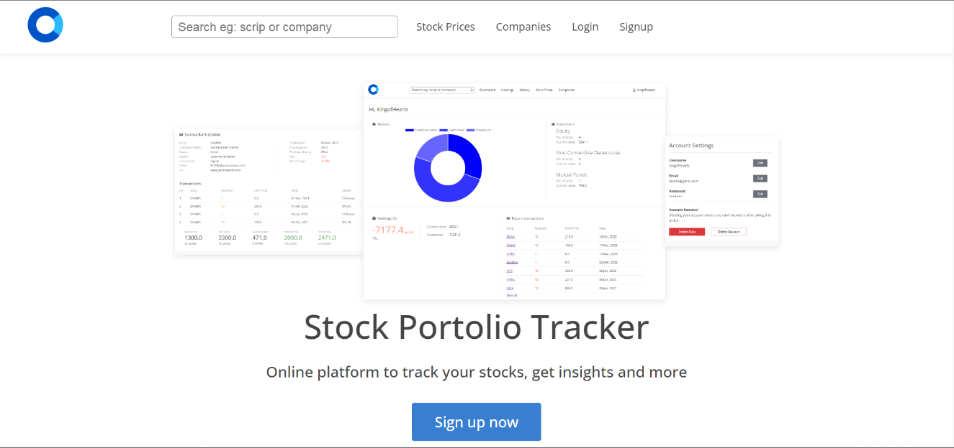

Login Page
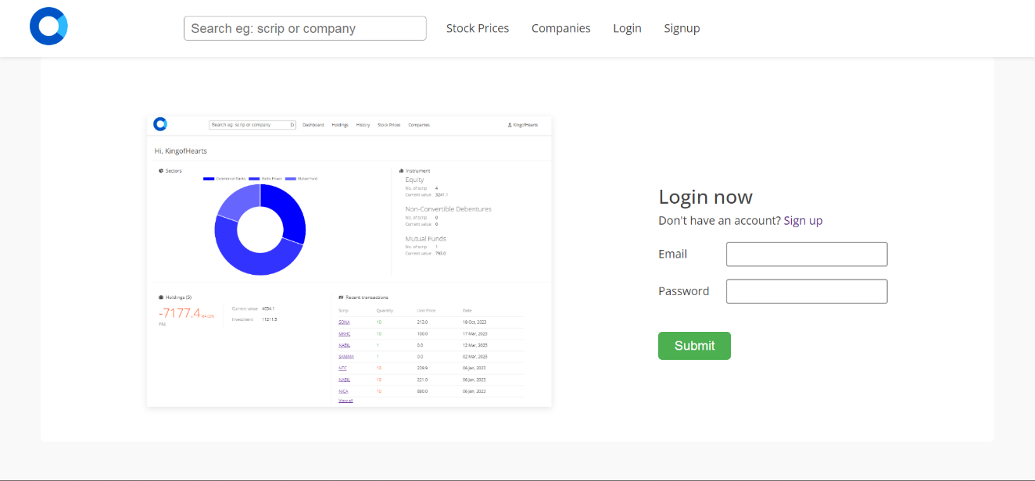

Signup page
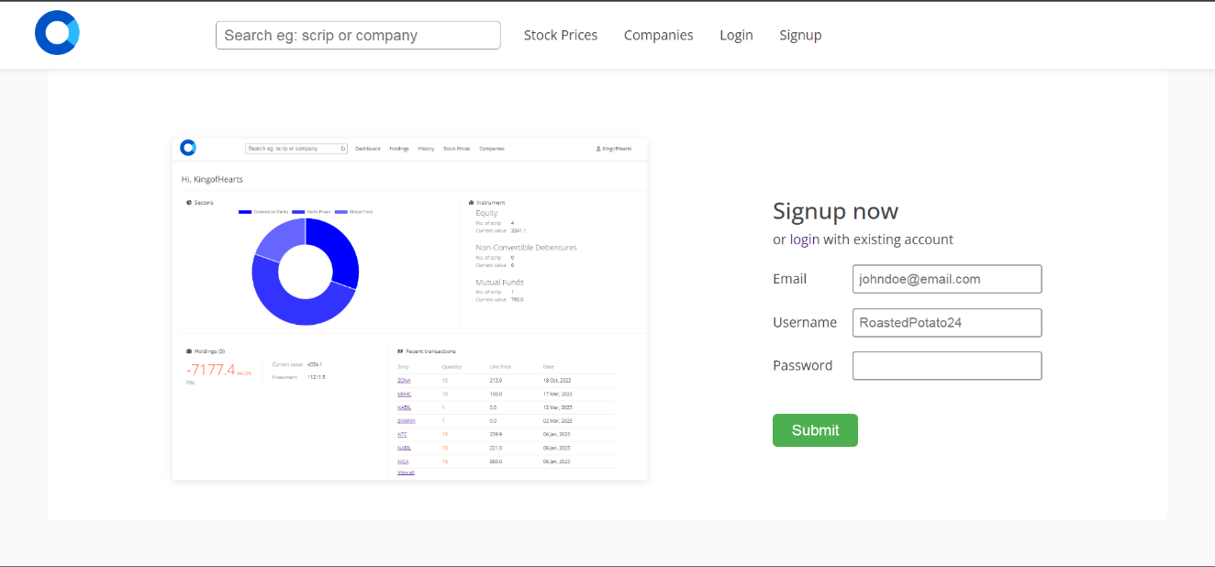

Dashboard – Portfolio Section
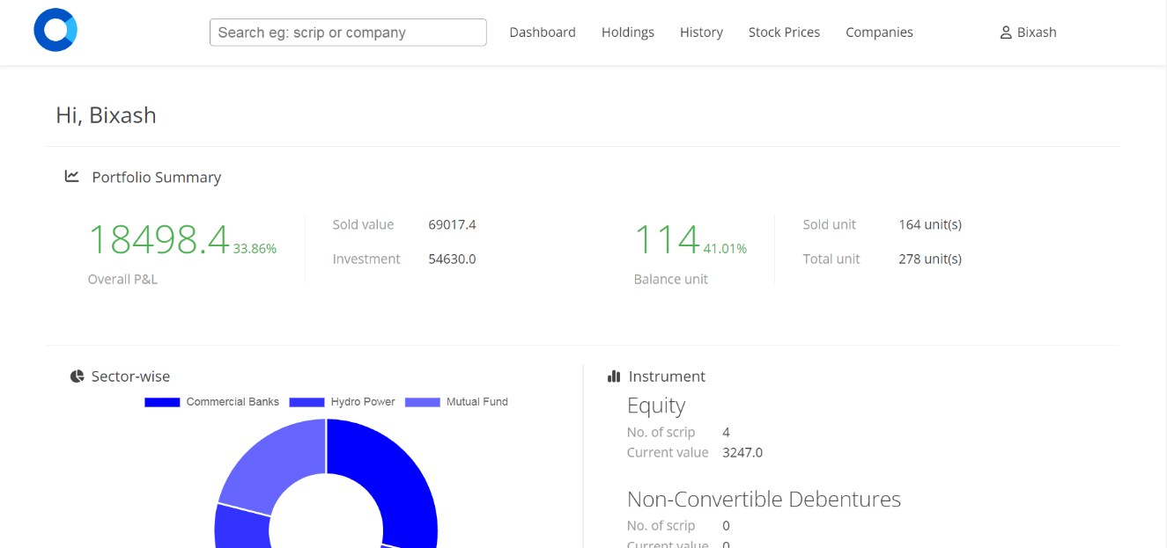

Dashboard – Holdings/Transactions Section
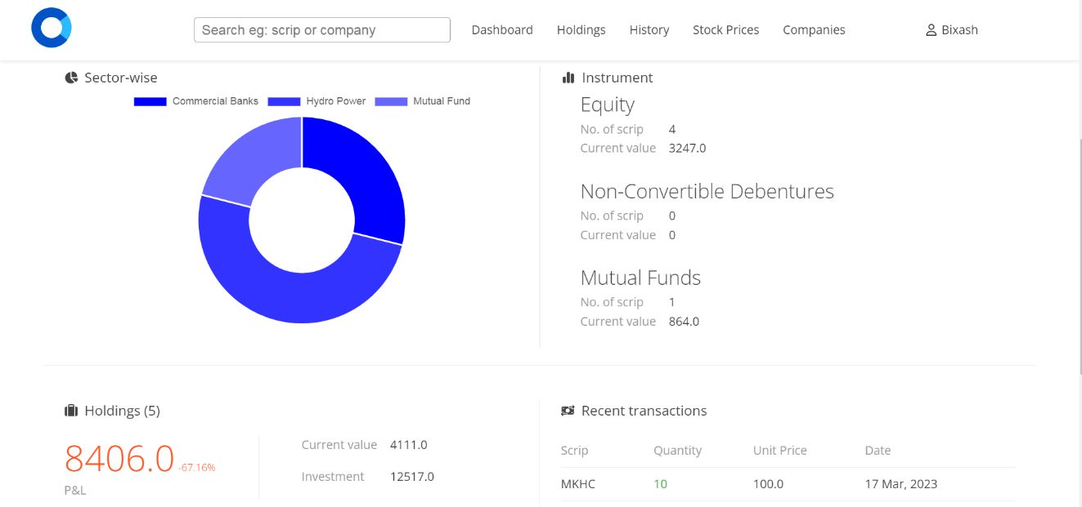

Holdings Page
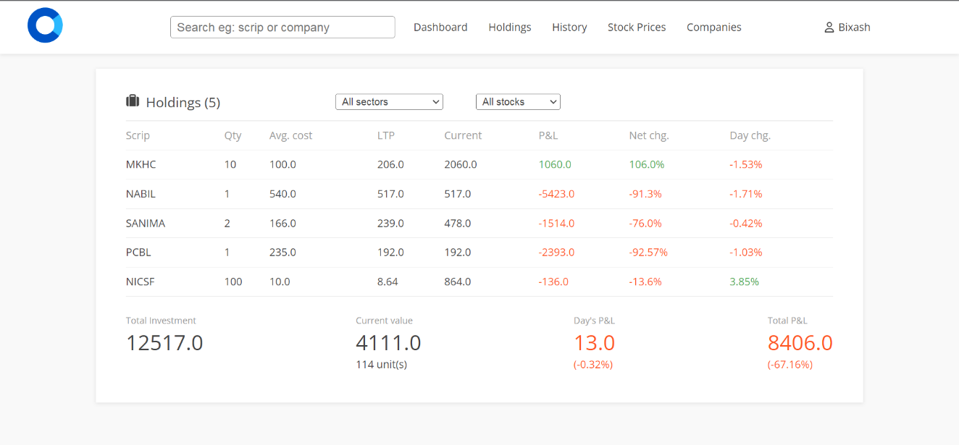

Company Page
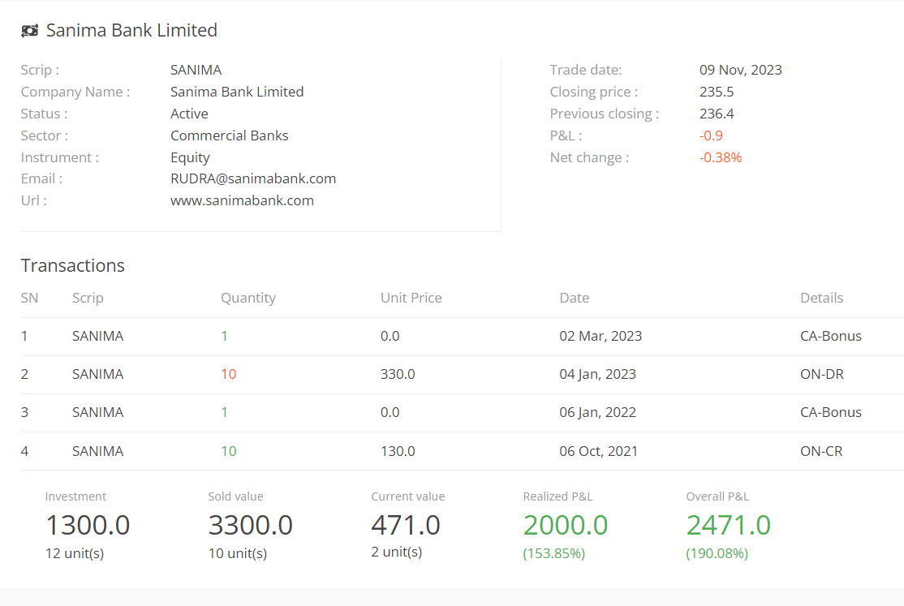

History Page
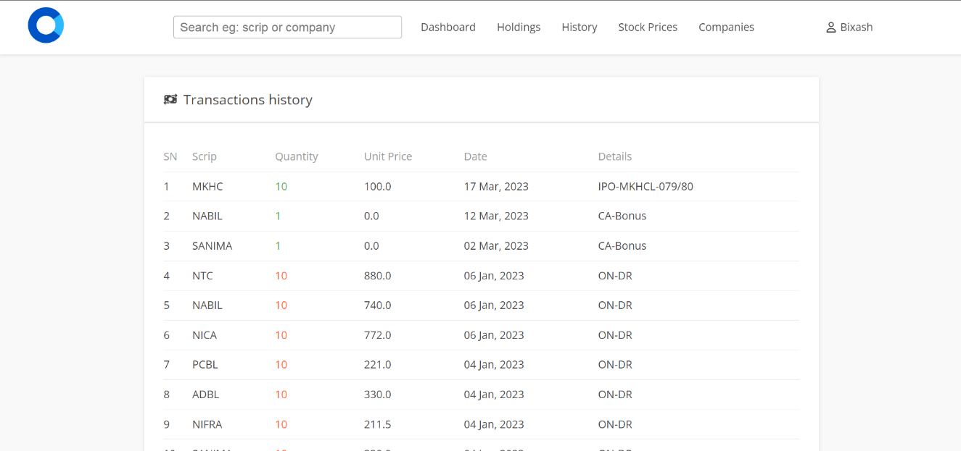

Stock Price Page
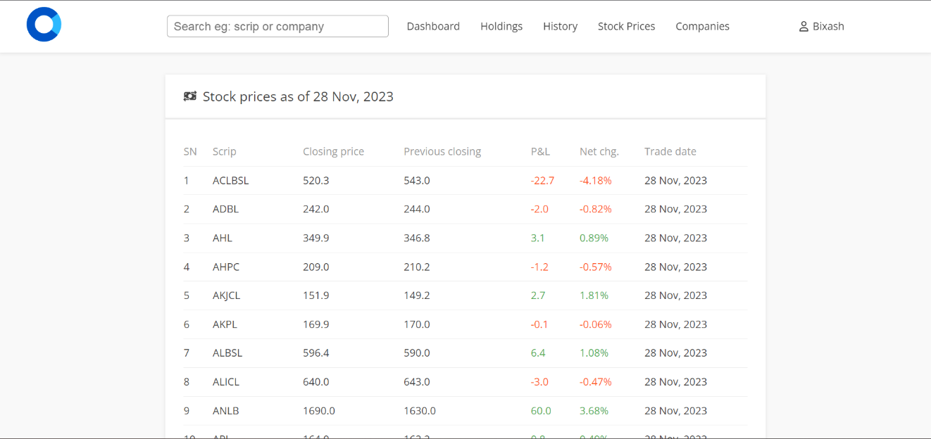

User Account Page
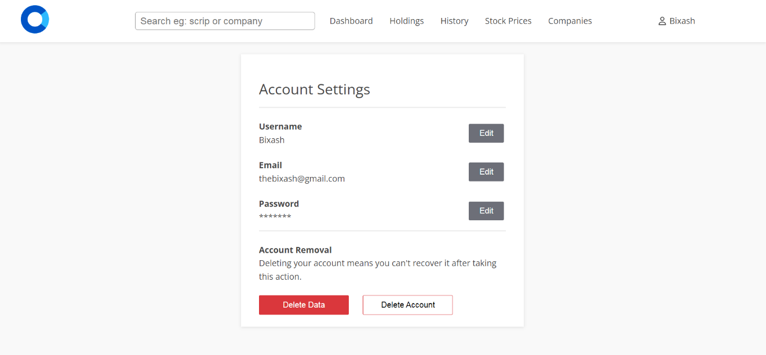

Upload Page
